Automotive Immersion Day Labs

This hands-on lab will guide you through a series of steps to showcase how AWS services fit into the context of Automotive. The labs will help you to understand device connectivity, data generation, real-time notification, and the analysis of the generated data.

# Prerequisites

You will need an active AWS account to setup these resources. Note that launching the AWS CloudFormation script will result in costs for the underlying instance used.

**Note**: This workshop reuses the setup of the AWS IoT Workshop.

## Amazon EC2 Instance Setup

### Step 1 - Launch the AWS CloudFormation Template

This AWS CloudFormation template creates an Amazon EC2 instance. Click **Deploy to AWS** to get started. The CloudFormation template allows you to use your default VPC or create a new one. The IAM roles used during the workshop are created for you.

Right-click the appropriate link and choose **Open Link in New Tab**.

[Deploy to AWS](https://console.aws.amazon.com/cloudformation/home?region=us-east-1#/stacks/new?stackName=automotive-prep-workshop&templateURL=https://s3-us-west-2.amazonaws.com/iotworkshop/ec2-cf-fast.json)

This action opens a browser page with the CloudFormation template selected. Click **Next** to start populating the required fields.

### Step 2 - Configure the Stack

If you’re using a shared account make sure that you’re using a different prefix for each launched workshop. All resources created will use this prefix.

1. Enter a name and prefix for your workshop. If multiple participants are using the same AWS account then add name/short name to the prefix for both the Stack name and Workshop name. For example:

automotive-prep-workshop-<*shortname*>  
AWSWorkshop-<*shortname*>

otherwise, stack creation will fail. The same name will be used to create Role, etc. so it must be unique.

1. Enter a username and password for accessing your C9 instance. Use a strong password as this instance has SSH access via the browser.

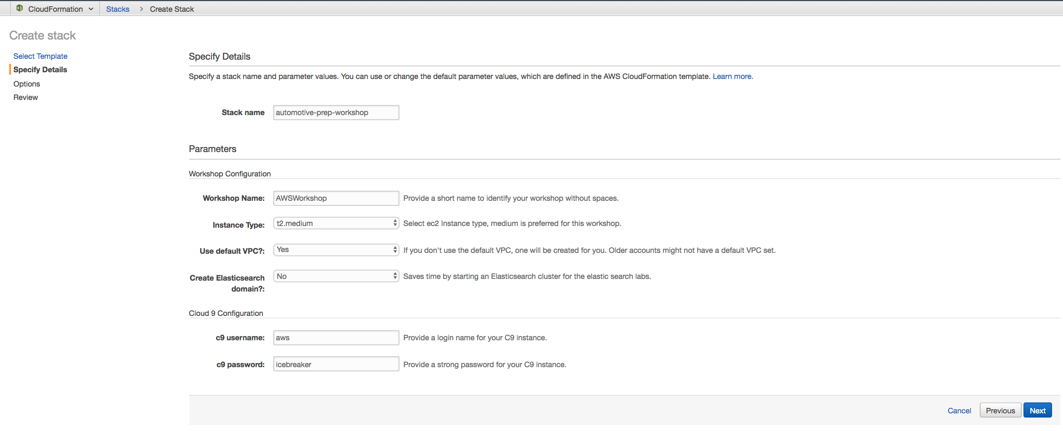

1. On the next screen click **Next**.
2. On the final screen, review the settings, check the acknowledgement at the bottom of a summary page, and then click **Create**. The process will take five to seven minutes to complete, and then the **Output** tab for the stack will provide a link to the **Workshop Website**.

### Step 3 - Accessing the Web Portal

After the CloudFormation is complete, you will have a public IP address for your workshop. Click the link to access the portal and get started!

[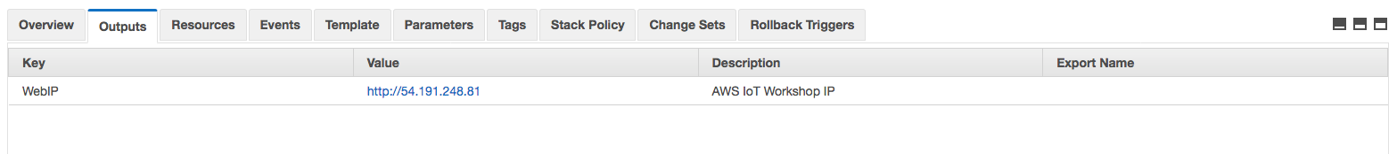](https://d3th31e9l34d0a.cloudfront.net/ec2-4.png)

**Note**: If you are redirected to a web page with a countdown, just wait—your workshop is still building. This workshop uses a public IP address. If you subsequently start this instance from the EC2 console, you can find its public IP address on the EC2 instance page.

[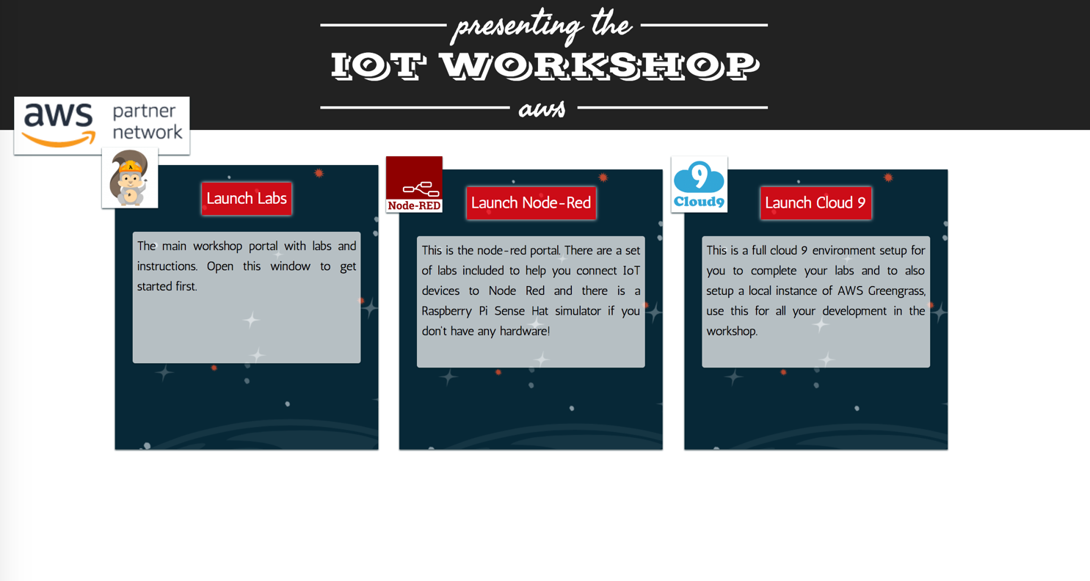](https://d3th31e9l34d0a.cloudfront.net/ec2-8.png)

In some rare cases, you will only see an Apache welcome screen after clicking on the portal link. If this happens, delete the CloudFormation stack and try again.

### Step 5 - Start with the Labs

Click the **Launch Cloud9** link to get started with detailed workshop instructions.

Note: Ensure that you are not connected to a VPN or any restricted network as these might prevent you from connecting to the Cloud9 IDE. Also ensure security group allow access for port 3389.

The Cloud9 IDE will give you access to running scripts required for the lab, uploading your certificates, executing console commands on your EC2 instance, and more. Use Cloud9 to run the scripts as directed in the lab. Some steps that direct you to copy files to your server can be done with Cloud9 by dragging and dropping the files into your workspace.

* Cloud9 username: aws (or your changed username)
* Cloud9 password: icebreaker (or your changed password)

[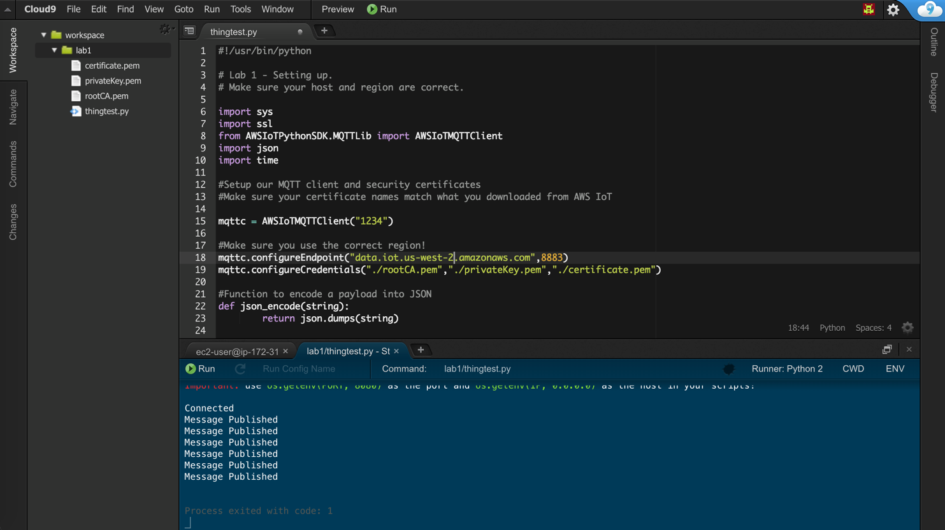](https://d3th31e9l34d0a.cloudfront.net/ec2-7.png)

# Lab 1: Connect Device to IoT Core

**Note**: All workshop examples are performed on your connected device or your Amazon EC2 instance.

## Step 1 - Creating your First “Thing”, Security Policies, and Certificates

Let’s get your account set up with a new device, certificates, and security policies.

Log into your AWS console and make sure that you are in the same region you ran Cloud formation and access **AWS IoT Core** service. Click on **onboard**. It should look similar to the following:

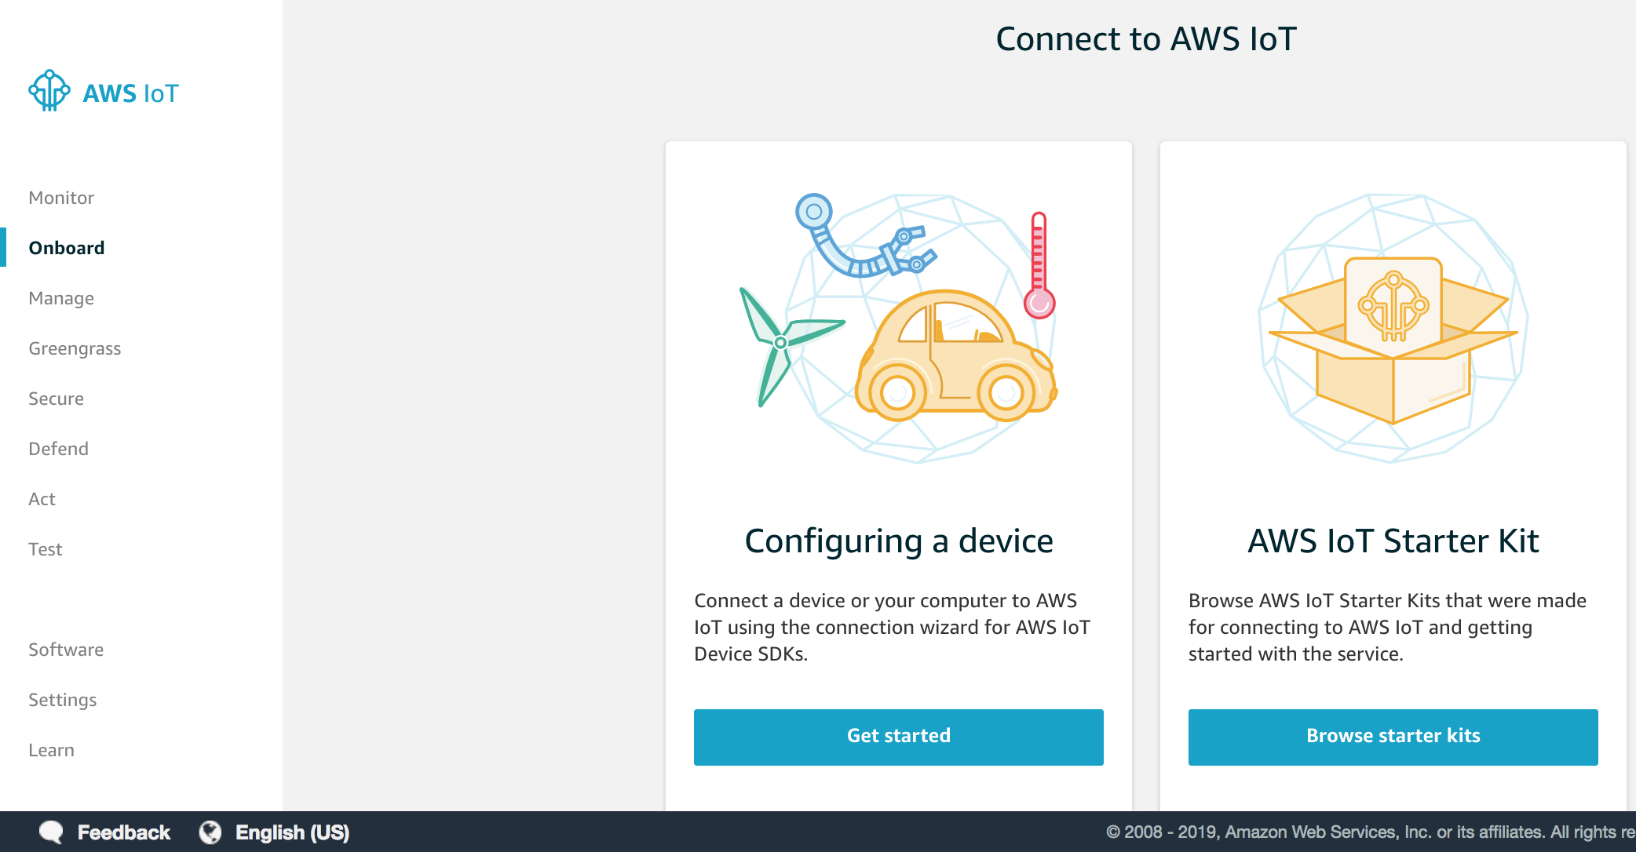

Let’s configure our first “device” and set up the policy and certificates for this to work.

We’re going to select **“Configuring a device”** and click the Get started button.

## Step 2 - Connect to AWS IoT

The **Connect to AWS IoT** screen will appear. Click the **Get started** button to continue.

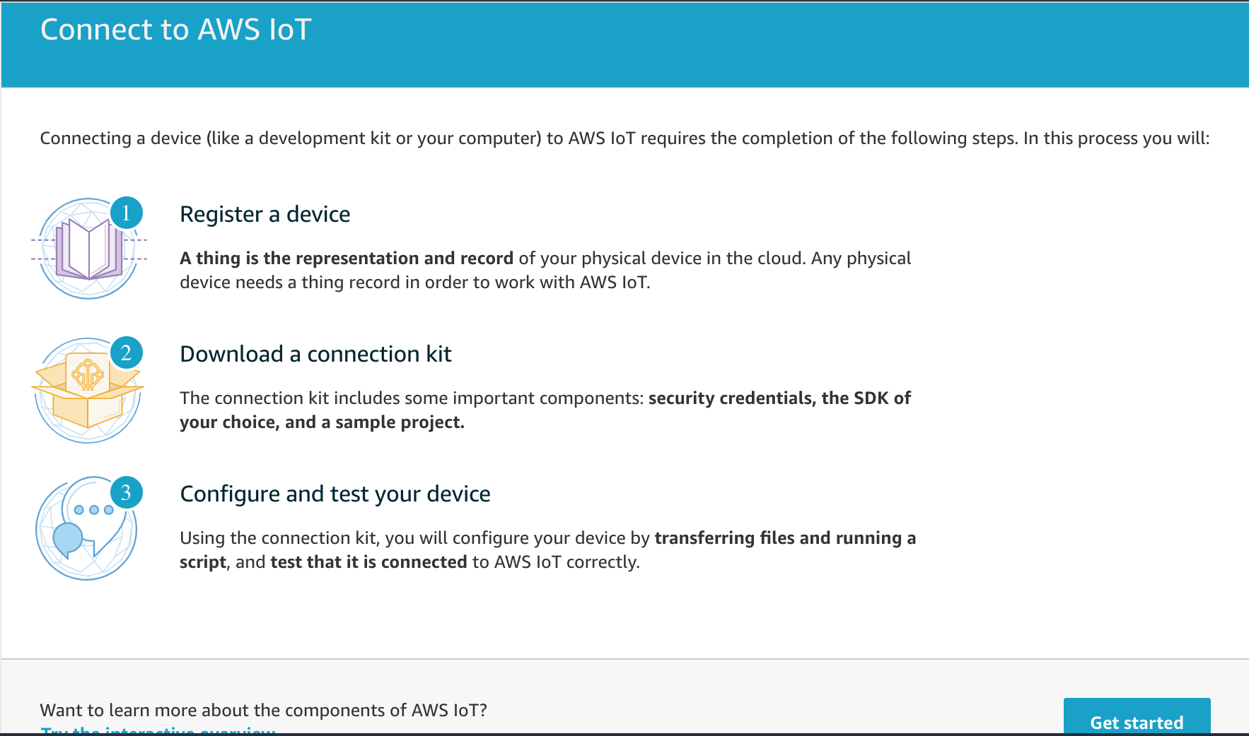

Next, we’re going to pick our target operating system and development language. This is used to generate a full package for us to quickly connect to AWS IoT.

[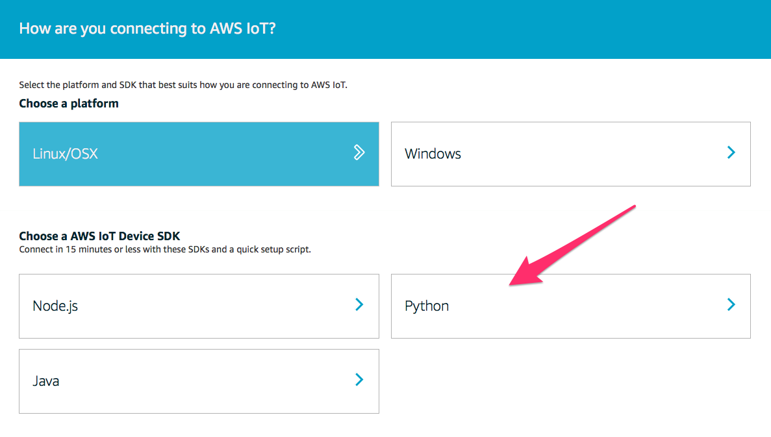](https://d3th31e9l34d0a.cloudfront.net/lab1-3.png)

For the hardware we’re working on today let’s pick Linux/OSX as our platform and Python for our SDK.

You will now see the **Register a thing** screen.

## Step 3 – Register a Thing

To begin, click **Getting started** and enter a name for your new thing. For these labs let’s call our new thing **tcu**. Enter this name and click **Next step**.

Note: If you’re using a shared account, add your first name followed by a hyphen to this name to make it unique, for example: <*name*>-tcu

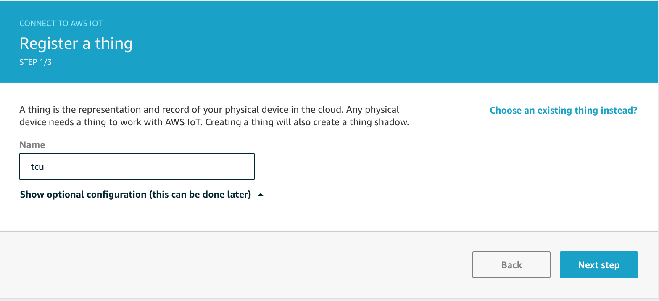

On the next screen, you can see that everything has been generated for you!

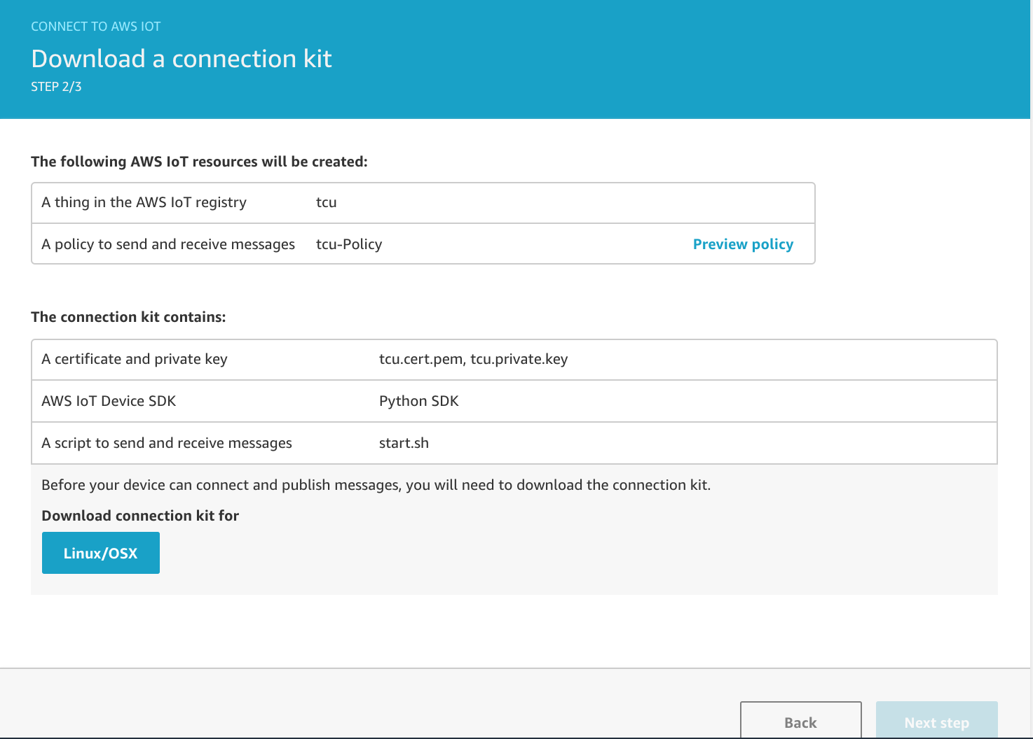

So let’s see exactly what was generated:

* You’ll notice a security policy has been created for you allowing you to immediately send and receive messages.
* A **start.sh** script has been created. This script will download any additional files needed, including a sample application.
* Finally, a Linux/OSX zip file containing all your certificates.

Make sure that you click the **Linux/OSX** link to download the connection package.

**Note**: Do not lose this zip file as it contains your private key file, which cannot be retrieved again.

After you have downloaded the zip file you’ll be able to click the **Next step** link.

Click **Done** to complete the wizard.

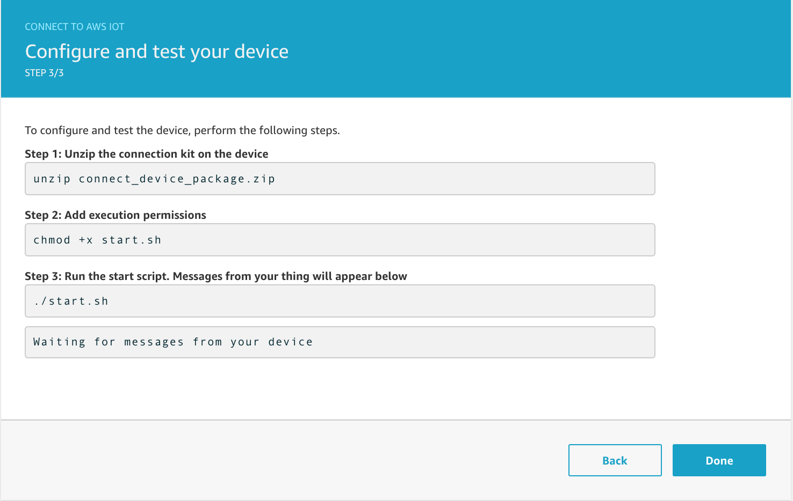

**Note**: **Do not run the scripts on the last page of the wizard**, just click **Done**. Those scripts are not used in this lab.

You will see the following screen:

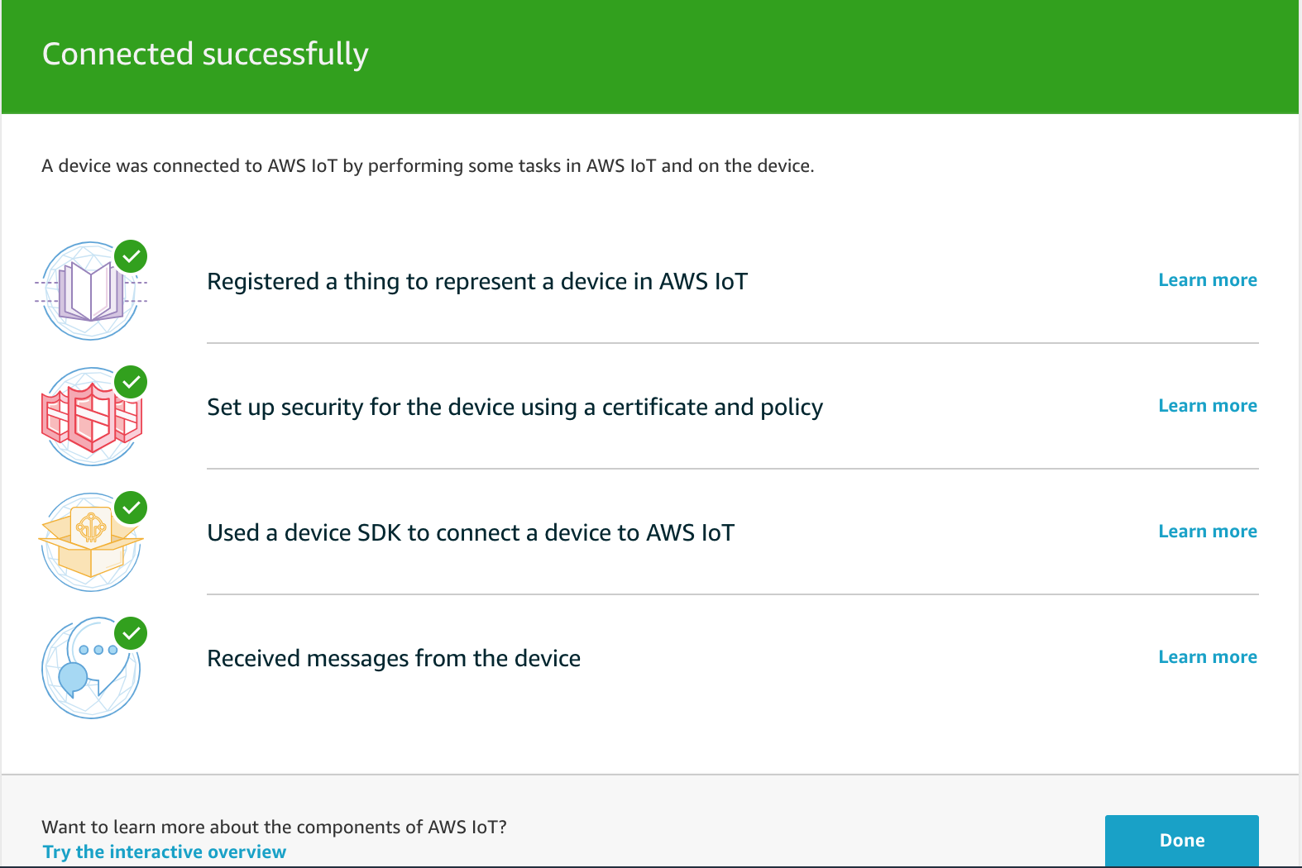

## Step 4 - Adjust our “Thing” Security Policy

The default security policy created by the wizard will limit the topics your device can publish on. For the labs in this workshop we’re going to create a more open policy (**only meant for this lab, not for production use!**) So we need to find and edit the policy that has been created already.

1. In the IoT Console click **Manage**. It will default to **Things**.
2. Find the thing you just created, in this case look for **tcu**.

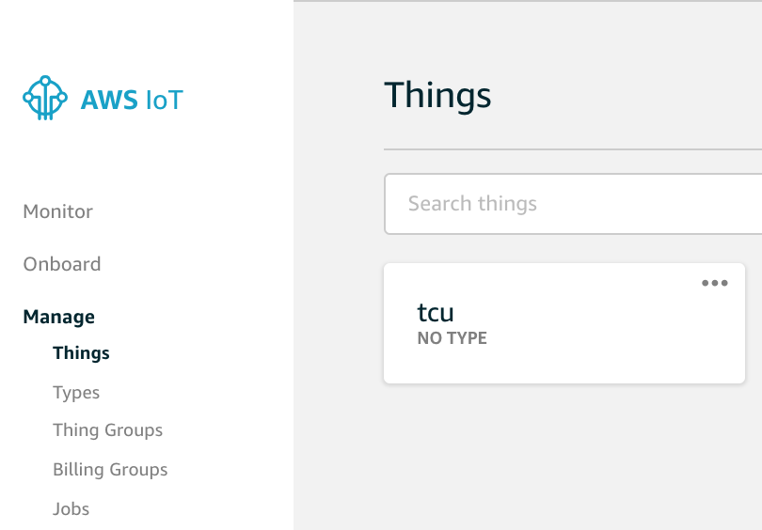

1. Click on your device to see its details.
2. Click **Security**.
3. Click on the attached certificate, as shown below:

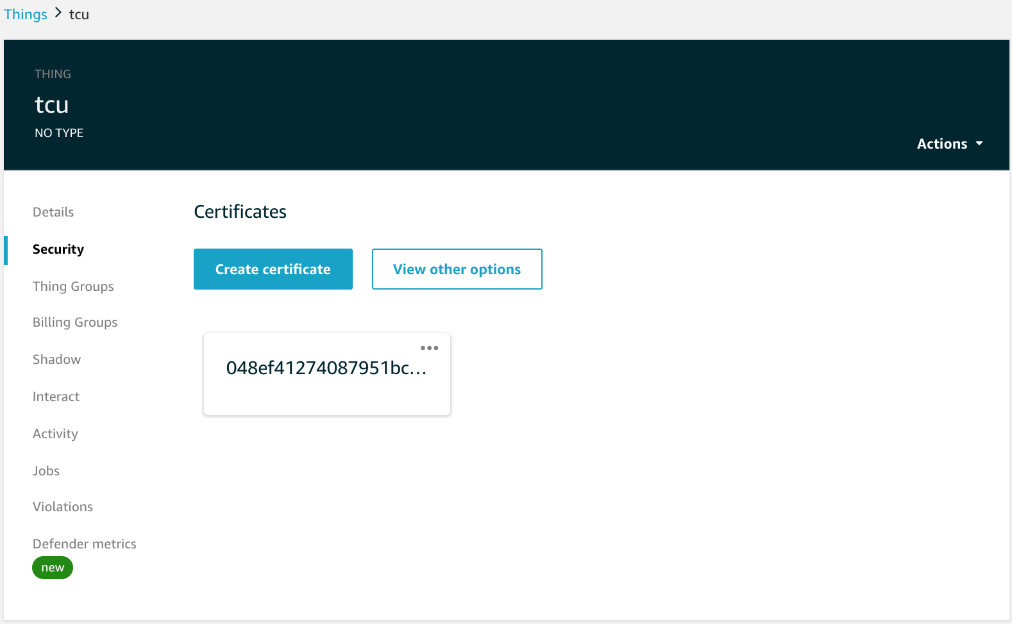

You will see your certificate details.

1. Click **Policies.**

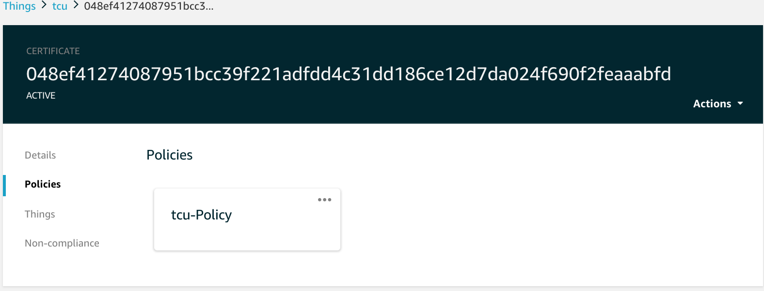

1. Click on your policy, usually that’s **tcu-Policy**.

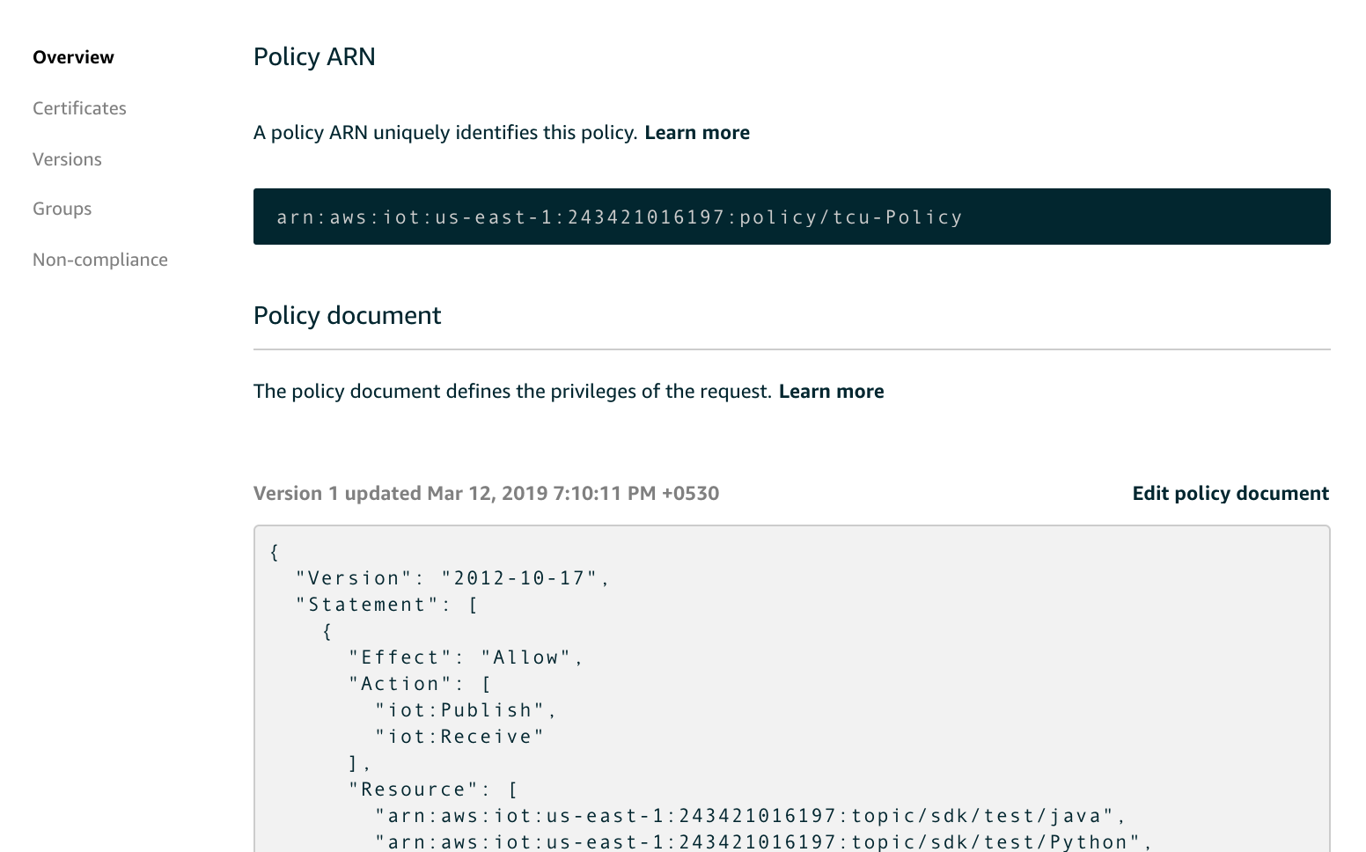

1. Click **Edit Policy Document.**
2. Enter the following for your document:

{

"Version": "2012-10-17",

"Statement": [

{

"Action": [

"iot:Publish",

"iot:Subscribe",

"iot:Connect",

"iot:Receive"

],

"Effect": "Allow",

"Resource": [

"*"

]

}

]

}

1. Click **Save as new version.**

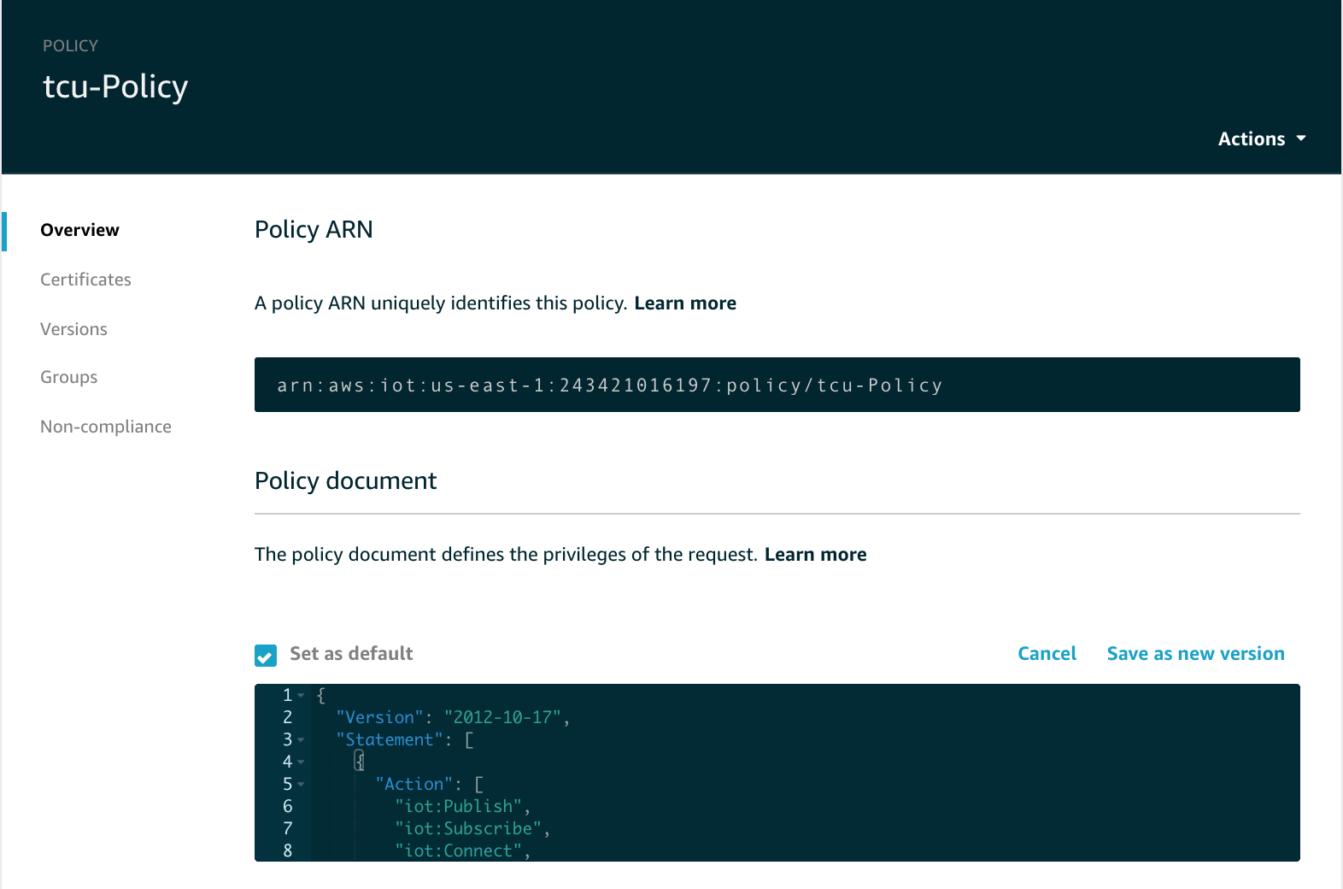

That’s it! your device can now publish and subscribe to any topics.

## Step 5 - Quick Review

Let’s have a quick review:

* Your certificates have been created *and* activated for you.
* A security policy has been created and modified for the access we need.
* The certificate and security policy have been attached to the thing “**tcu**” that you created.

The above are the three required components to use AWS IoT.

## Step 6 - Copy Files to Your Device

We need to put these certificates on our device or EC2 instance. Using the Cloud9 IDE, we can easily upload these:

1. Extract the certificates from the zip file you downloaded above.
2. Open your Cloud9 environment.
3. Click **File** -> **Upload Local Files.**

[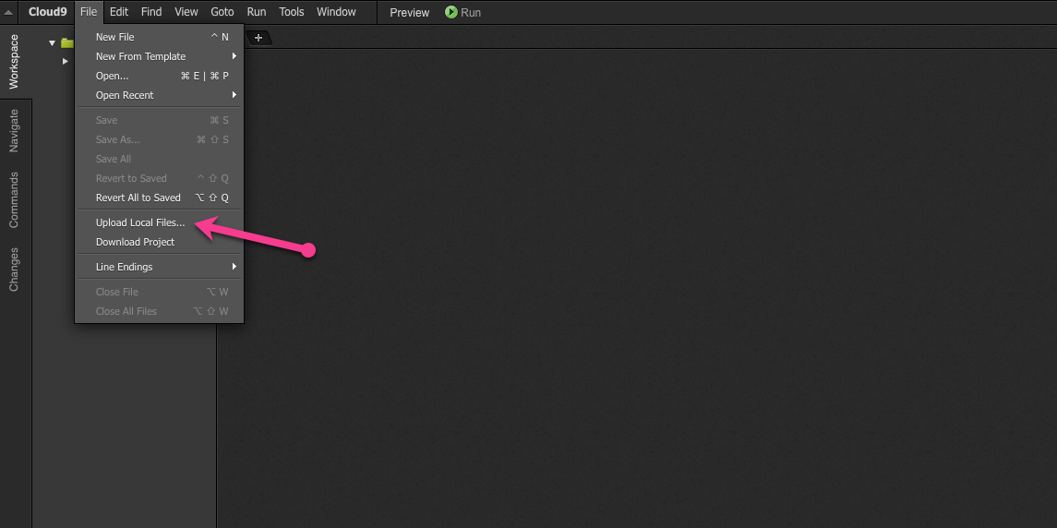](https://d3th31e9l34d0a.cloudfront.net/lab1-11.png)

1. Drag and drop your certificate and private key to the upload window or browse for the files.
2. You can now rename the files to match the workshop content.
3. Your certificate should be called **tcu.cert.pem**
4. Your private key should be called **tcu.private.key**

**Note**: Make sure that the certificates are in the same folder as your test code. In this example, that folder would be **/lab1**. A copy of the **rootCA** file must also reside in this folder.

## Step 7 - Test

Now we need to create our test script on our device or EC2 instance.

1. Open your Cloud9 IDE.

You will see a terminal window where we can enter our bash commands.

[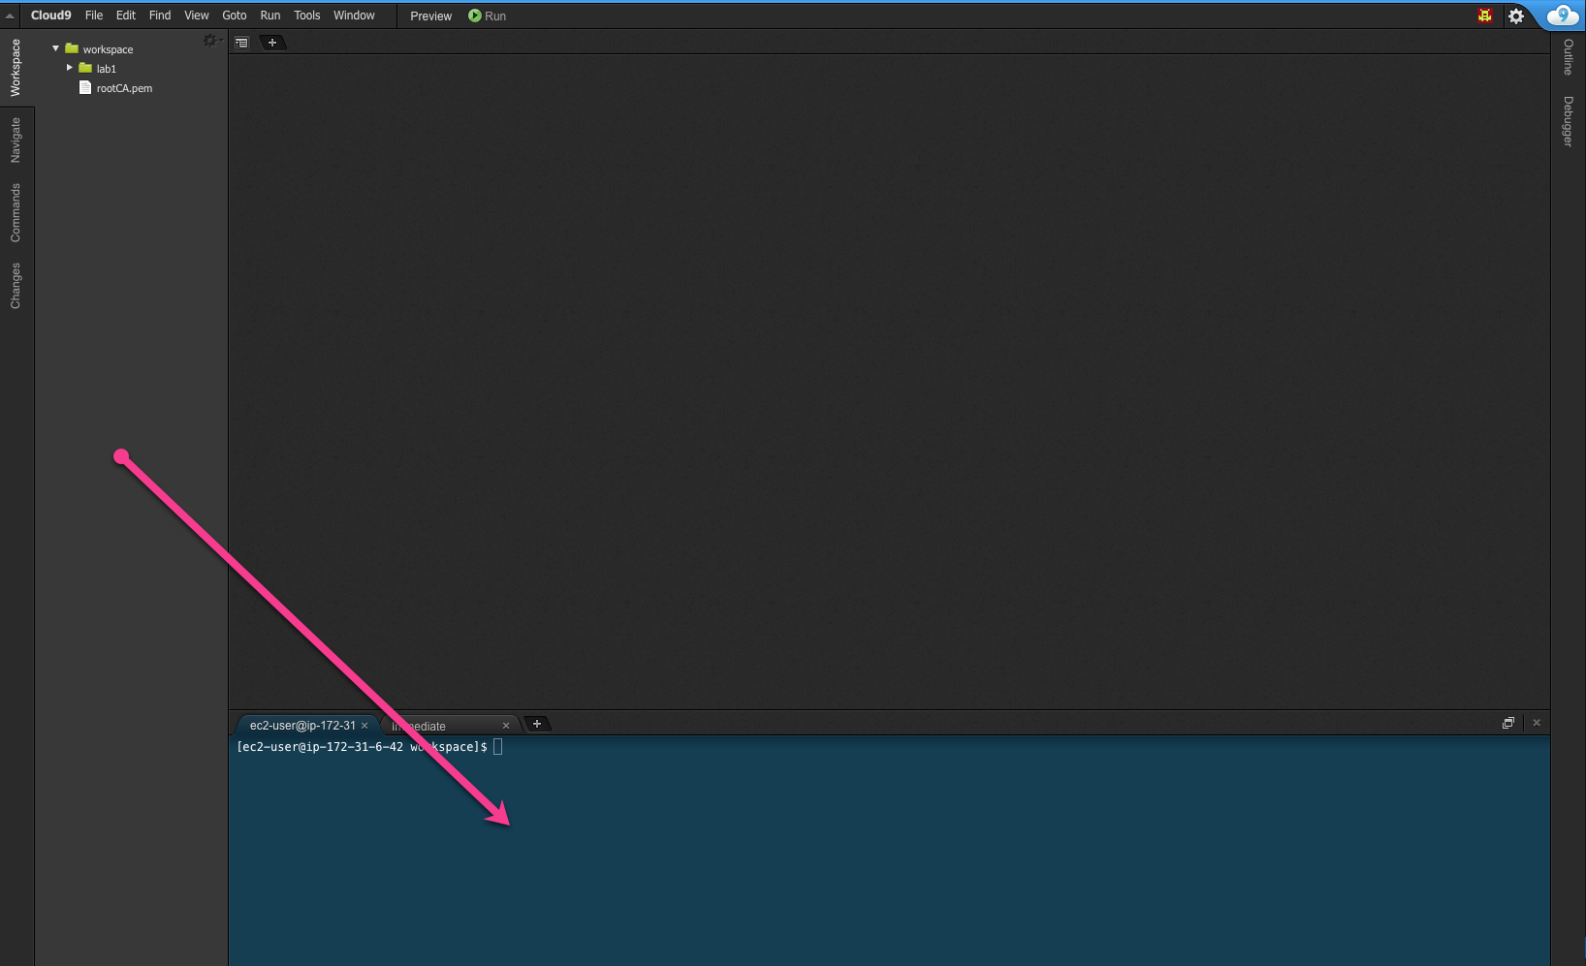](https://d3th31e9l34d0a.cloudfront.net/lab1-12.png)

1. In your **lab1** folder you will see the starter **ratchet.py** file.
2. Make sure that your **AWS Region** in the code is correct! Look at mqttc.configureEndpoint and make sure that it matches.
3. Make sure that your certificates are in the same location as the file that you’re running, or edit the code to add the path of your certificates.

Now you are ready to run the lab. This can be done on the Raspberry Pi or the Amazon EC2 instance.

Rename the **rachet.py** file in the **lab1** folder to **tcu.py.**

Change in the **tcu.py** file as below. Every **tcu** will have a unique ID and that ID will be used as client ID for AWSIoTMQQTClient. Create a unique ID, e.g., VIN. Also Change your message as shown below to simulate the behavior of **tcu** and publish message to topic ‘**tcu’**.

#!/usr/bin/python

# Lab 1 - Setting up.

# Make sure your host and region are correct.

import sys

import ssl

from AWSIoTPythonSDK.MQTTLib import AWSIoTMQTTClient

import json

import time

import uuid

import random

import datetime

#you can use http://randomvin.com/ to generate a VIN number

VIN = "1HGCP2F31BA126162"

#Setup our MQTT client and security certificates

#Make sure your certificate names match what you downloaded from AWS IoT

mqttc = AWSIoTMQTTClient(VIN)

#Make sure you use the correct region!

mqttc.configureEndpoint("data.iot.us-east-1.amazonaws.com",8883)

mqttc.configureCredentials("./rootCA.pem","./tcu.private.key","./tcu.cert.pem")

#Function to encode a payload into JSON

def json_encode(string):

return json.dumps(string)

mqttc.json_encode=json_encode

#Declaring trip_id variables

trip_id = str(uuid.uuid4())

#This sends our test message to the iot topic

def send():

message = {

"name": "speed",

"value": 87,

"vin": VIN,

"trip_id": trip_id

}

#Encoding into JSON

message = mqttc.json_encode(message)

mqttc.publish("tcu/"+VIN, message, 0)

print "Message Published" + message

#Connect to the gateway

mqttc.connect()

print "Connected"

#Loop until terminated

while True:

send()

time.sleep(1)

mqttc.disconnect()

#To check and see if your message was published to the message broker go to the MQTT Client and subscribe to the iot topic and you should see your JSON Payload

Execute the **tcy.py** script using **Run** button in Cloud9 IDE.

To check and see if your message was published to the message broker, go to the MQTT Client and subscribe to the iot topic and you should see your JSON Payload.

1. Open the AWS IoT Console.
2. Click **Test.**
3. Subscribe to: #

[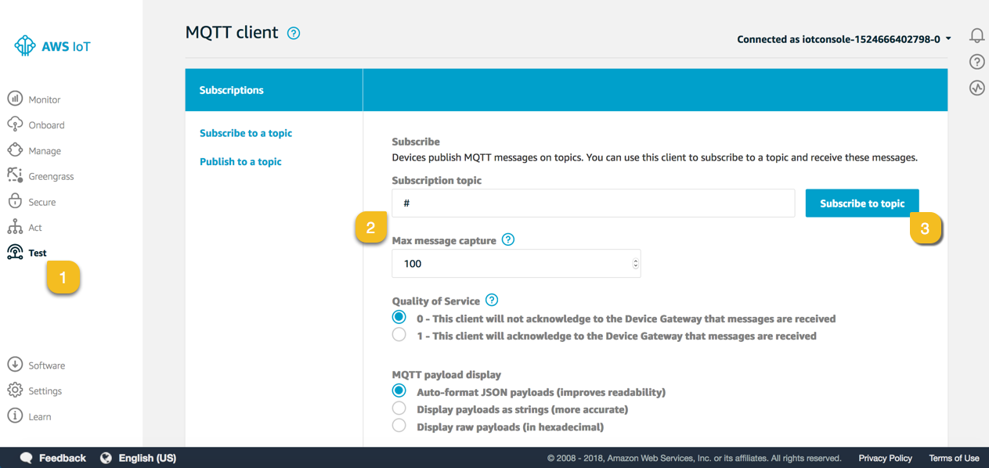](https://d3th31e9l34d0a.cloudfront.net/lab1-10.png)

Stop the **tcu.py** execution.

Now generate the random value for speed, and add timestamp column as below.

message = {

"name": "speed",

"value": random.randint(0,120),

"vin": VIN,

"trip_id": trip_id,

"timestamp": str(datetime.datetime.now())

}

If you are facing any problem in running the python code then extract the **tcu.py** file from zip file [Connected Vehicle Lab Files](https://smrt-parking.s3.amazonaws.com/connected_vehicle_lab_files.zip)

Let’s simulate the vehicle behavior and send message specific to a vehicle. Change the topic to: **tcu/vehicle/<*VIN*>**

mqttc.publish("tcu/vehicle/" + VIN, message, 0)

Now subscribe to **tcu/vehicle/#** on Test Console and execute **tcu.py** by clicking **Run**.

# Notices

Customers are responsible for making their own independent assessment of the information in this document. This document: (a) is for informational purposes only, (b) represents current AWS product offerings and practices, which are subject to change without notice, and (c) does not create any commitments or assurances from AWS and its affiliates, suppliers or licensors. AWS products or services are provided “as is” without warranties, representations, or conditions of any kind, whether express or implied. The responsibilities and liabilities of AWS to its customers are controlled by AWS agreements, and this document is not part of, nor does it modify, any agreement between AWS and its customers.

© 2019 Amazon Web Services, Inc. or its affiliates. All rights reserved.